Order Of Service

Singing: Psalm 71—CW page 92

Reading: Psalm 81

Opening Hymn: TLH 7

Reading: Acts 13:34-41

Request Hymn: CW Supplement 749

Reading: Matthew 2:13-18

Sermon Hymn: TLH 514

Sermon Text: Mark 1:14-15

John In Prison

Prayer

The Apostles’ Creed, TLH page 12

Holy Communion

The Lord's Prayer

The Blessing

Closing Hymn: TLH 49

* * * * * * * * * * *

Bible Study: Lambs: Firefly
Sheep: Romans 16:1-16
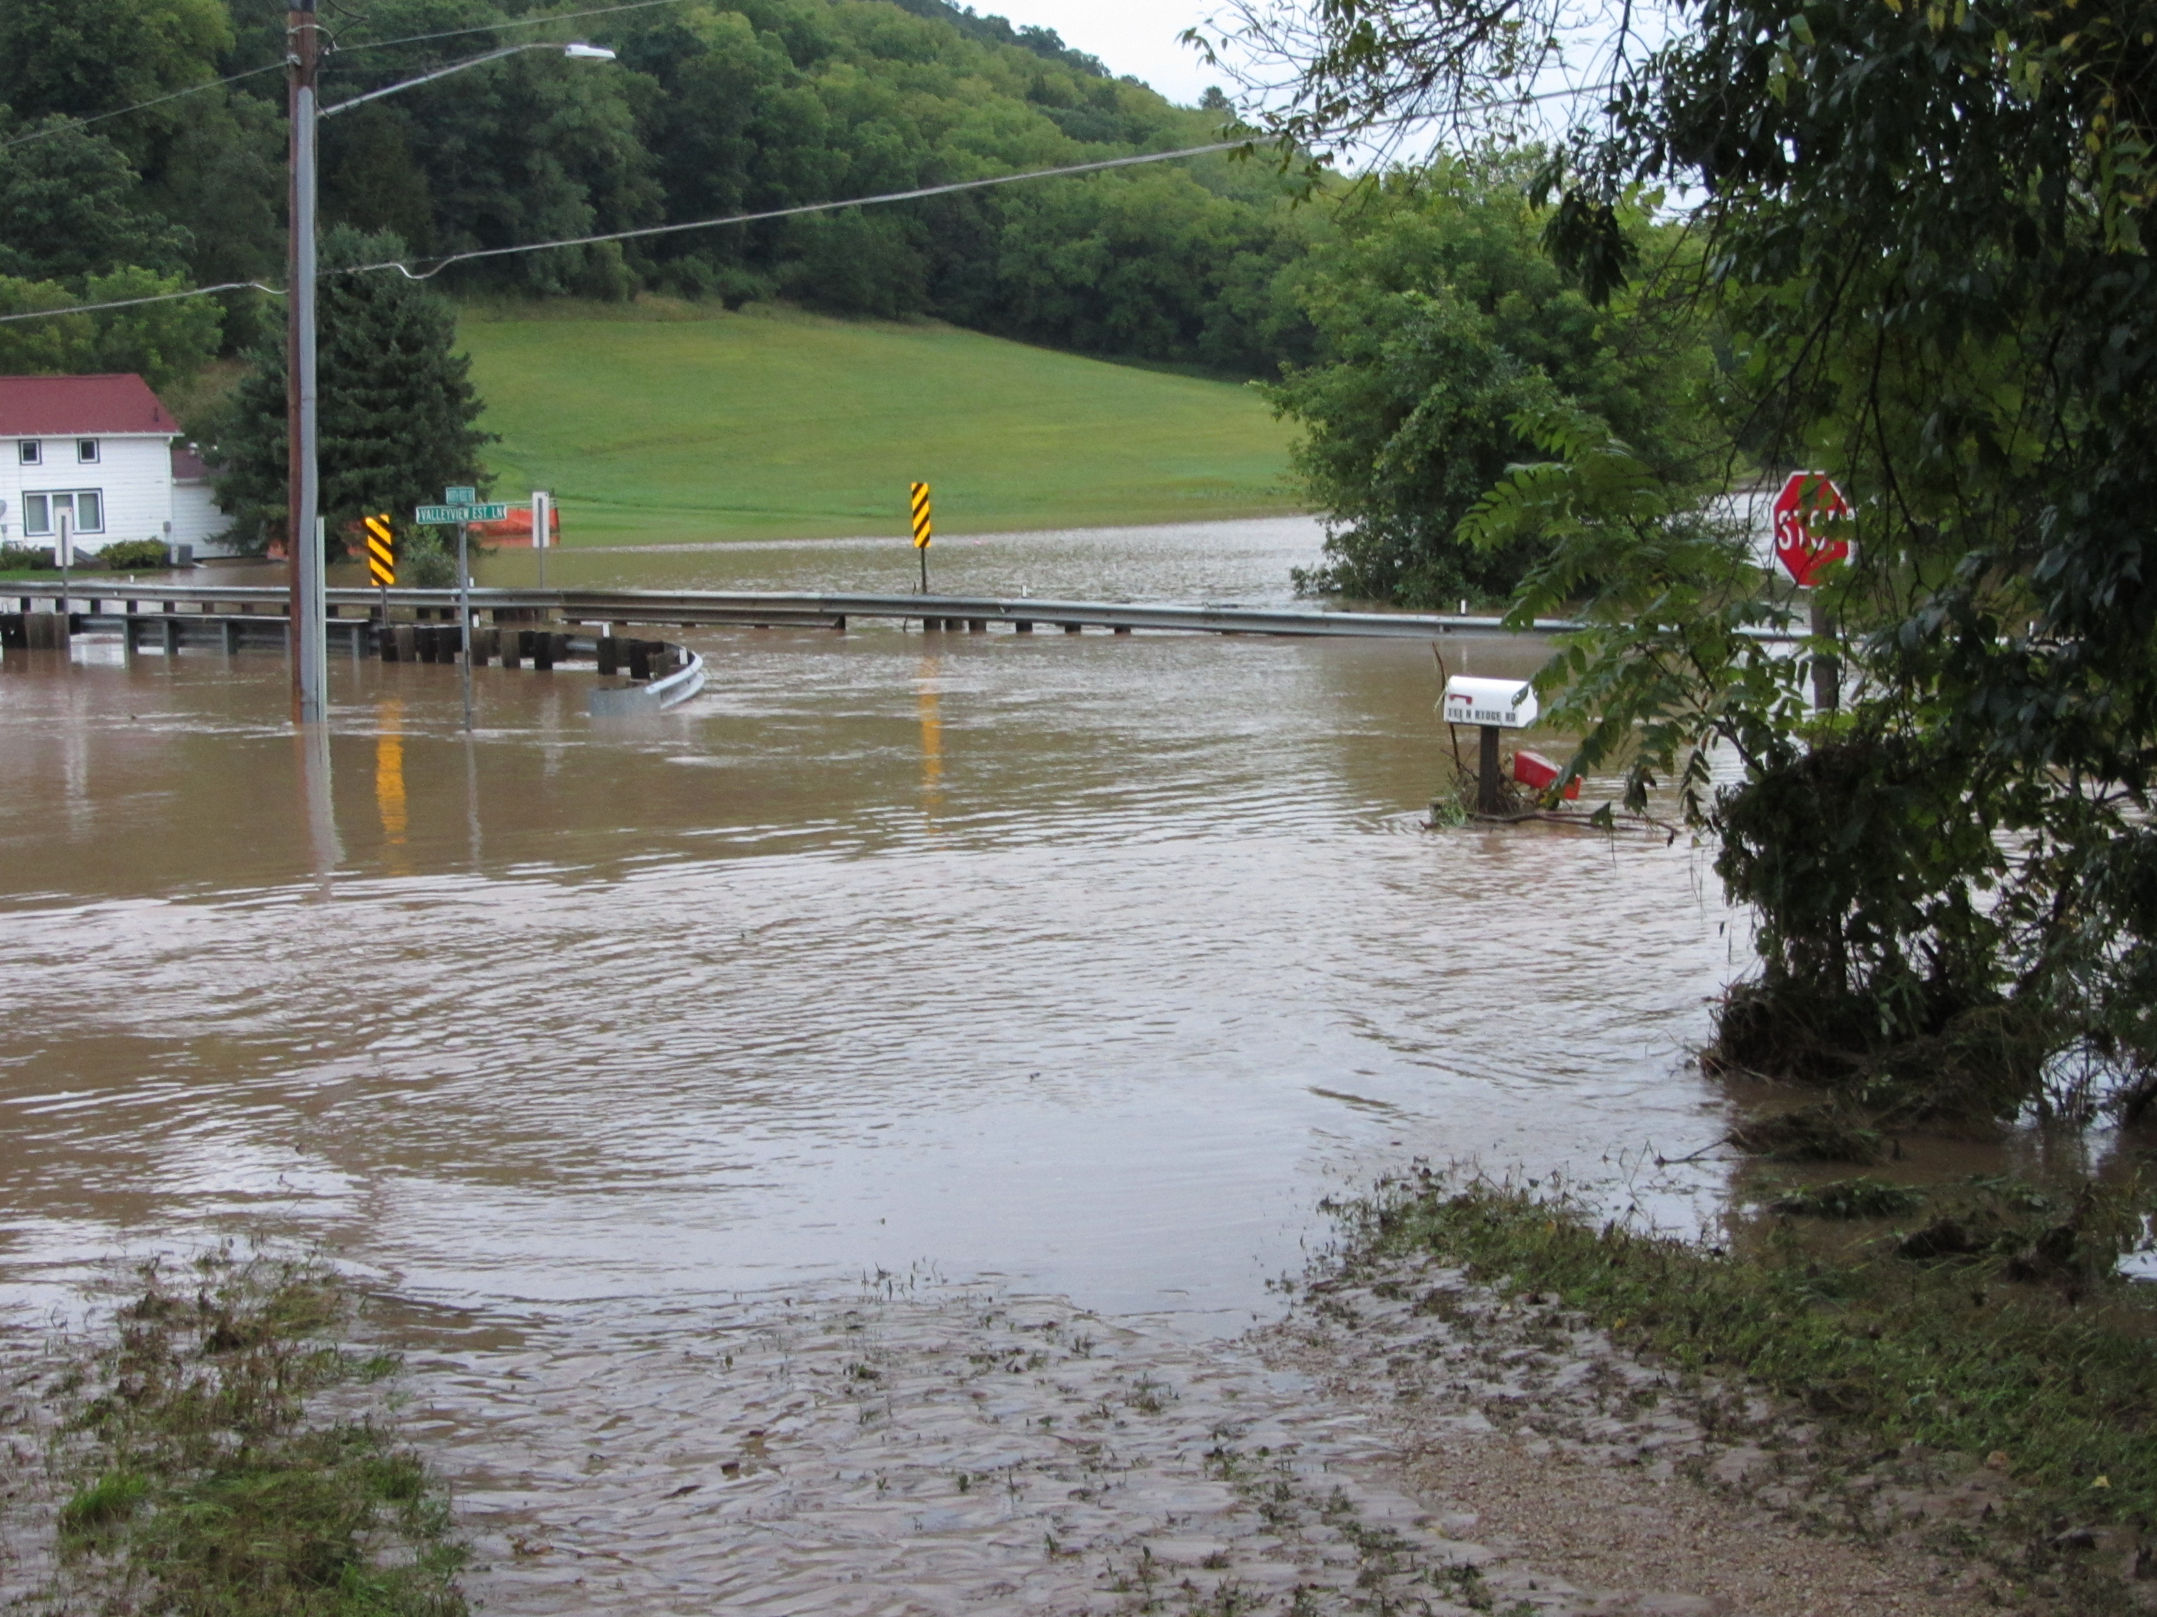

Flood Stage At MGMF

Water
Of
Life

30 September 2018

W A T E R O F L I F E

Independent Christian Church—Conservative Lutheran Doctrine

Worship Service: 9:30 a.m. Bible Study: 10:45 a.m.

Larry Cooper, Pastor E-Mail address:
111 N. Ridge Road lcooper@wateroflife.cc
Coon Valley, WI 54623 Web Site:
Phone: (608) 452-2105 www.wateroflife.cc

* * * * * * * * * * * * * * * * * * * * * * * * * * *

Sermon Text: Mark 1:14-15

John In Prison

* * * * * * * * * * * * * * * * * * * * * * * * * * *

Mark 1:14 Now after that John was put in prison, Jesus came into Galilee, preaching the gospel of the kingdom of God,
:15 And saying, The time is fulfilled, and the kingdom of God is at hand: repent ye, and believe the gospel.

_____________

Related Reading: II Peter 3:1-13

1 This second epistle, beloved, I now write unto you; in both which I stir up your pure minds by way of remembrance:
2 That ye may be mindful of the words which were spoken before by the holy prophets, and of the commandment of us the apostles of the Lord and Saviour:
3 Knowing this first, that there shall come in the last days scoffers, walking after their own lusts,
4 And saying, Where is the promise of his coming? for since the fathers fell asleep, all things continue as they were from the beginning of the creation.
5 For this they willingly are ignorant of, that by the word of God the heavens were of old, and the earth standing out of the water and in the water:
6 Whereby the world that then was, being overflowed with water, perished:
7 But the heavens and the earth, which are now, by the same word are kept in store, reserved unto fire against the day of judgment and perdition of ungodly men.
8 But, beloved, be not ignorant of this one thing, that one day is with the Lord as a thousand years, and a thousand years as one day.
9 The Lord is not slack concerning his promise, as some men count slackness; but is longsuffering to us-ward, not willing that any should perish, but that all should come to repentance.
10 But the day of the Lord will come as a thief in the night; in the which the heavens shall pass away with a great noise, and the elements shall melt with fervent heat, the earth also and the works that are therein shall be burned up.
11 Seeing then that all these things shall be dissolved, what manner of persons ought ye to be in all holy conversation and godliness,
12 Looking for and hasting unto the coming of the day of God, wherein the heavens being on fire shall be dissolved, and the elements shall melt with fervent heat?
13 Nevertheless we, according to his promise, look for new heavens and a new earth, wherein dwelleth righteousness.

